Q1: simple code with if functions.

# This program prompts the user to enter three test

# scores. It displays the average of those scores and

# and congratulates the user if the average is 95

# or greater.

def main():

# Get the three test scores.

test1 = float(input('Enter the score for test 1: '))

test2 = float(input('Enter the score for test 2: '))

test3 = float(input('Enter the score for test 3: '))

# Calculate the average test score.

average = (________________________) / 3.0

# Print the average.

print('The average score is', average)

# If the average is 95 or greater,

# congratulate the user.

if average >= 95:

print('Congratulations!')

print('That is a great average!')

# Call the main function.

main()

Fill in the above empty place, and the debug this code. After you get this program to successfully run, capture its output and then close it!

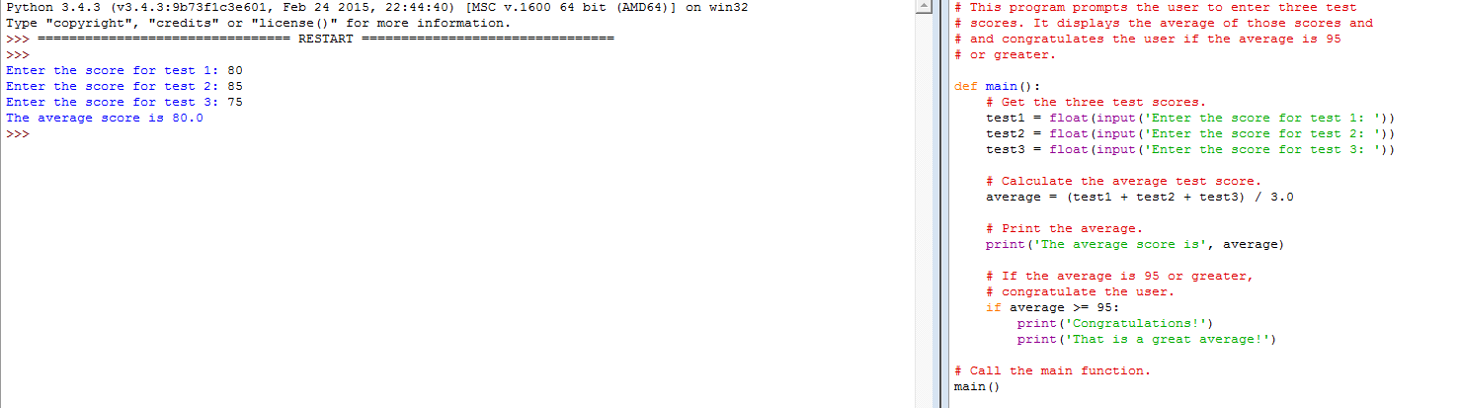

Q2: simple code with if-else functions.

# This program demonstrates how the == operator can

# be used to compare strings.

def main():

# Get a password from the user.

password = input('Enter the password: ')

# Determine whether the correct password

# was entered.

if password == 'prospero':

print('Password accepted.')

__________:

print(‘________________')

# Call the main function.

main()

Fill in the above empty place, and the debug this code. After you get this program to successfully run, capture its output and then close it.

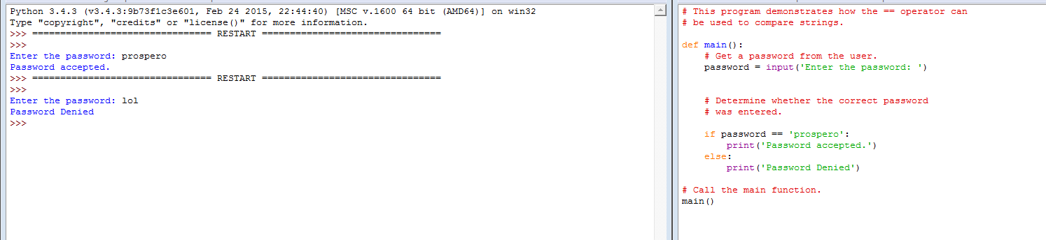

Q3: Determine the type of weather we're having

Part 1:

def main():

# Prompt the user to enter the temperature.

temp = float(input('What is the temperature outside? '))

# Determine the type of weather we're having.

if temp < 30:

print('Wow. That is cold.')

else:

if temp < 50:

print('A little chilly.')

else:

if temp < 80:

print('Nice and warm.')

else:

print('Whew! It is hot!')

# Call the main function.

main()

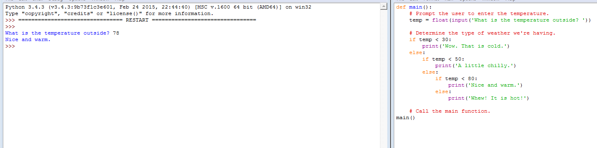

Part 2:

def main():

# Prompt the user to enter the temperature.

temp = float(input('What is the temperature outside? '))

# Determine the type of weather we're having.

if temp < 30:

print('Wow. That is cold.')

elif temp < _________________:

print('A little chilly.')

elif temp < __________________:

print('Nice and warm.')

else:

print('Whew! It is hot!')

# Call the main function.

main()

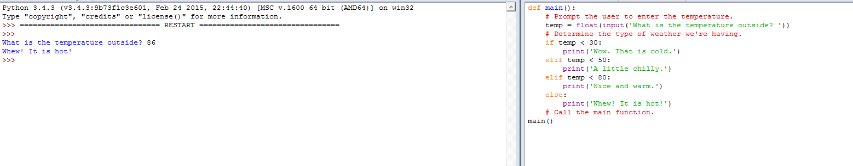

Part 3: Think about the following expression!

if x >= 20 and x <= 40:

if x < 20 or x > 40:

if not (temperature > 100):

sales_quota_met = False

As a result of this code, the sales_quota_met variable can be used as a flag to indicate whether the sales quota has been met. Later in the program we might test the flag in the following way:

if sales_quota_met:

print('You have met your sales quota!')

This code displays 'You have met your sales quota!' if the bool variable sales_quota_met is True. Notice that we did not have to use the == operator to explicitly compare the sales_quota_met variable with the value True. This code is equivalent to the following:

if sales_quota_met == True:

print('You have met your sales quota!')